Note, blue highlights are things I would like to continue refining. Yellow highlights are the “deliverables” of the lab. Or in other words, what I would like the students to report on.

**Fourier Series: The Math Behind the Music**

**Introduction:**

You have been working at an Electronics Team Gurus (ETG) for several years, but they just transferred you to the Audio Engineering Department. It has been almost a decade since you took EE 224, so it might be time to review a little bit of math behind the music. To start, you dig through your closet to find your dusty Signals and Systems book. Upon skimming through the pages, you find some old notes about Fourier Series equations.

**Prelab:**

Before coming to work, or in this case lab, you need to make sure that you are familiar with the math behind the music.

Fourier Analysis is the process in which a signal can be approximated using a sum of sinusoids.

Theses are the equations from Dickerson’s Fourier Lab. I would like to have the students at least calculate a_0 of a square wave which should be 0.5 (DC offset). Dickerson’s lab provides a great explanation of these equations and I think those explanations should be integrated into this lab. I have not explained them thoroughly yet.

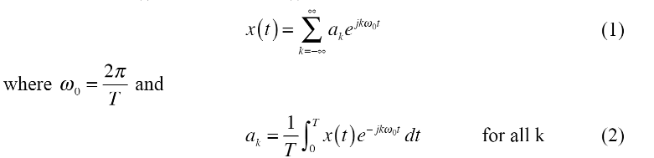

Here I would like to draw out a Reimens sum to help students understand what is going on a little better. Something similar to this quick drawing I made.

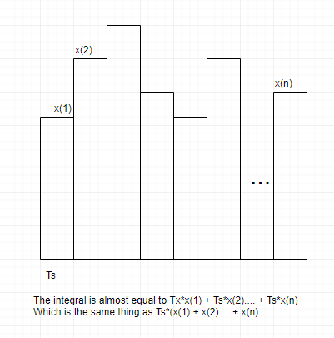

Ts = 1/fs, in that the sample time is 1 divided by the sample rate.

T is the number of samples multiplied by Ts. So, the number of samples is T/Ts.

I would like feedback on what makes these equations confusing and how we can better explain them.

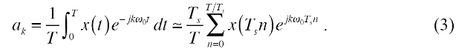

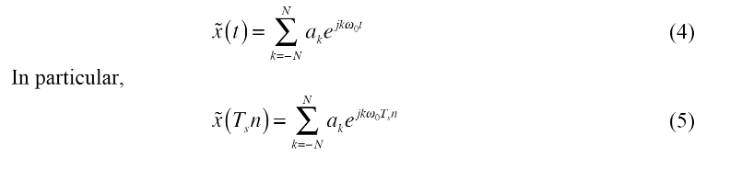

If the fundamental frequency that an instrument is playing is 440 hz, corresponding to a1, then the next harmonic is k*440 hz. What is the second, third and fourth harmonics? (hint: these correspond to a2, a3, and a4 where k = 2, 3 and 4 respectively.

If the trumpet was sampled at 44.1 kHz and there are 170 samples in a period, what is the fundamental frequency the trumpet’s note? How long is the period? This concept will be used later in the lab, so remember how it is done.

The note that is heard when an instrument is played is the fundamental frequency. However, a piano and a trumpet do not sound the same even if they are playing they are playing a note at the same frequency. This is because each instrument has a different “timbre,” or sound to it. This is because an instrument playing a C at 440 hz will have different magnitudes for the harmonics. In other words, the instruments will have different values for a2, a3, a4 ect. Changing these harmonics will affect how the instrument sounds.

A steel string guitar compared to a piano has a very similar sound. They both use steel strings to create this sound, so it makes sense. By looking at the coefficients for ak, why do you think this is? These two instruments sound somewhat similar, but a piano is used for tuning other instruments. Compare the fundamental frequency (a1) with the third harmonic (a3) for both the guitar and the piano. If listening to the fundamental frequency is most important when tuning an instrument, why is a piano preferred for tuning instead of a guitar? (hit: the fundamental frequency is when k = 1).

**Guitar:**

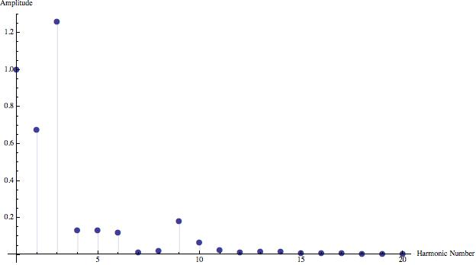

**Piano:**

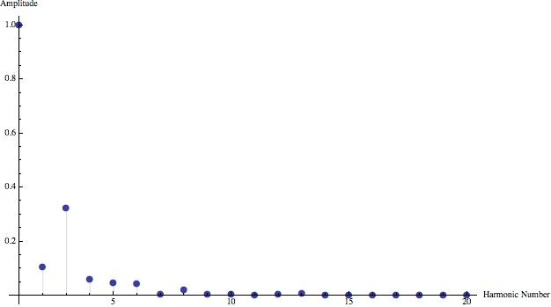

**Oboe:**

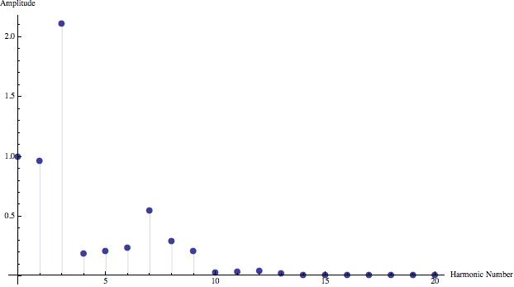

Optional: bring an instrument or other device that can create a constant tone.

**Experiment 1:**

Doing the calculations for a single coefficient is simple enough, but doing so for thousands of them can be a bit tedious. As an audio engineer, you will be tasked with sampling and recreating many different signals. So, you decide to be proactive and write a function in MatLab that will do the calculations for you.

Create a function that can compute a coefficient of a Fourier Series by taking the sampling rate, a wave file as input, a starting point, and an ending point.

The function should be like so: find_ak(x, k, fs)

Where x is the samples

K is the coefficient to be found

And fs is the sampling rate

At this point, students will generate a square wave and record the data with the CyDAQ. But, they many use the **gen_square** script for now.

Test find_ak.m on the square wave to find a-2- a1. Check with a TA before moving on because this one function is essential for the rest of the lab.

Use the function find_aks.m and then compare the results of a0 to those in the prelab.

Create a function that synthesizes an approximate waveform by taking in a_k coefficients.

% C is the vector of a_k coeficients

% f is the desired frequency to recreate

% fs is the desired new sample rate

% It can be used to control the

% amount of sample time between functions

% ss is the starting point of a_k in C

% ff is the ending point of a_k in C

% but ff may or may not be necessary

% depending on the implementation

function synth = fsynt(C, f, fs, ss, ff)

Use this function to synthesize the square wave using a_ks -10 to 10. Using plots in MatLab, compare this to a synthesized waveform that has a_ks from -1 to 1 and then one that has a_ks from -100 to 100.

What happens as the a_ks approach -infinity to infinity?

**Experiment 2:**

Since you showed initiative, your boss has put you in charge of making a synthesizer. Your boss asked you to create sounds that will be played on the company's new line of digital keyboards. To save space in the memory, it was proposed to use fourier coefficients to store the data instead of stored the sampled waveforms.

Use the CyDAQ to sample your voice, a tuning fork, musical instrument, or other device than can create a consistent tone. Since the CyDAQ is not up and going as of yet, use the trumpet.wav file for now. You could also record something using another mic. You only have to be able to get it into a .wav file format.

Use the provided function PlotPitch.m to plot the pitch. Find several areas that the pitch is consistent. Take the sample rate of the .wav file and the frequency found from PlotPitch.m to figure out how many samples long the fundamental frequency is. Your plot should look like the one below.

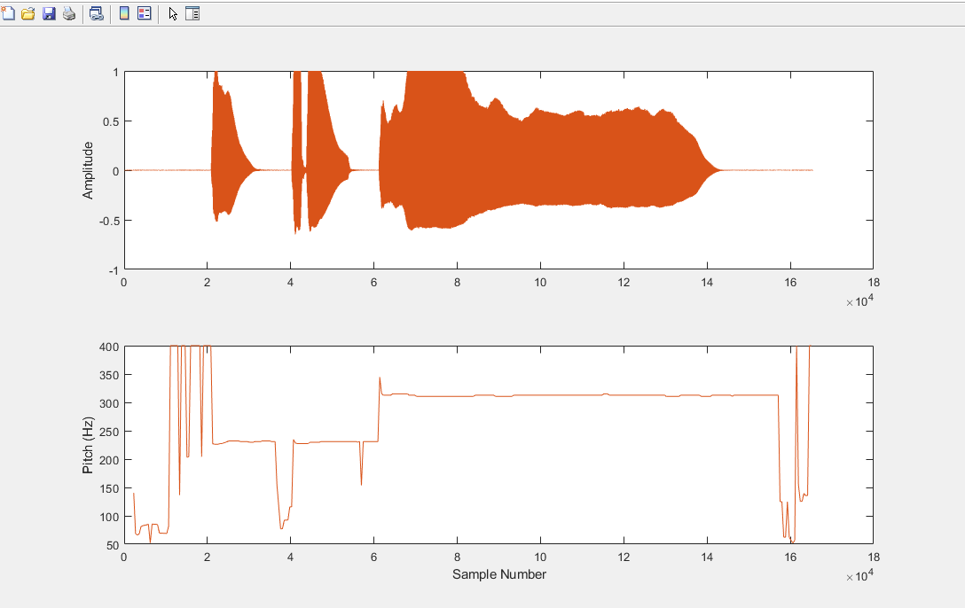

Knowing how many samples long a single Period is, zoom in to a section that has a constant tone. Go to Tools, Zoom in, and then click and draw until you can identify a periodic waveform.

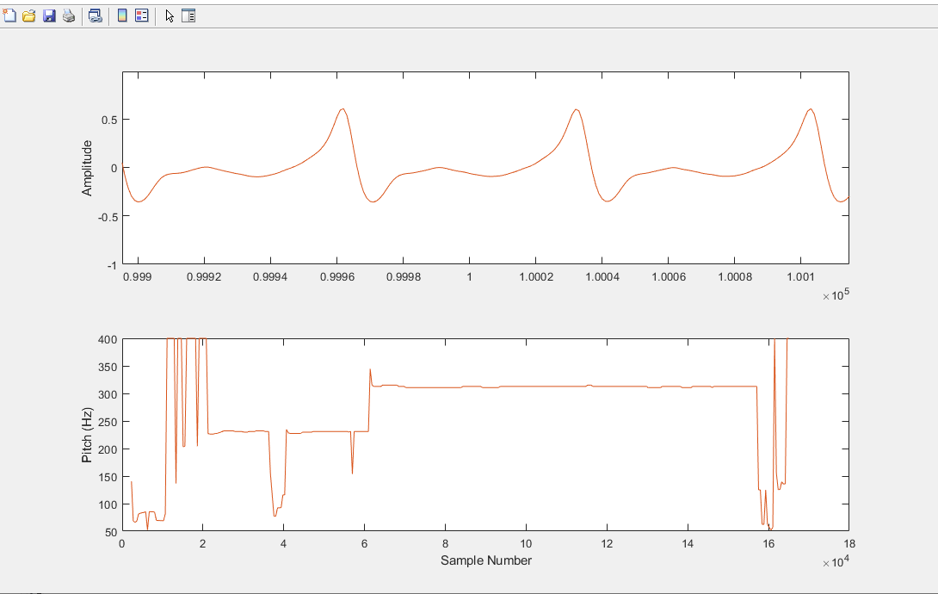

Use audioinfo(‘filename.wav’) to find the sampling rate if it is unknown. Use the sample rate and the frequency in the Pitch plot to find the amount of samples in one period. Use the Data Cursor found under tools to find a starting point in the plot.

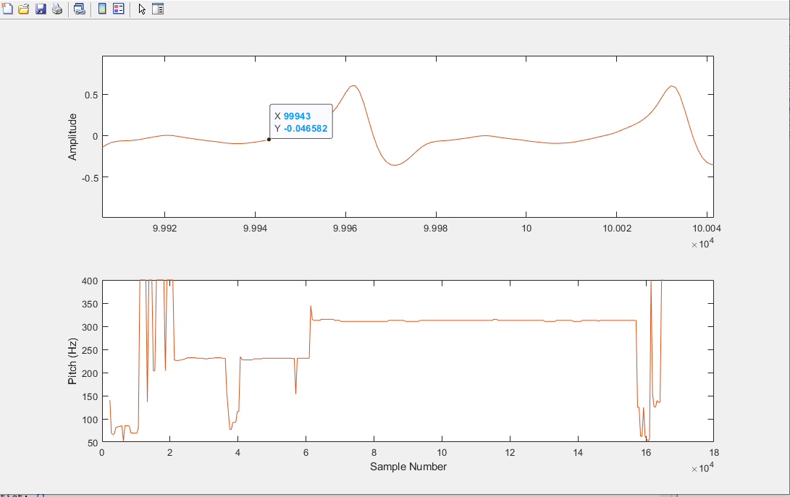

Once a starting point and the number of samples in a period have been found, CutSample.m to create a single set of samples to work with. Use the functions that were created in Experiment 1 to find the a_ks from -10 to 10. Plot their **magnitude.** How “pure” is the sound of the instrument that was sampled? (hint: compare the fundamental frequency to the other harmonics).

Use fsynt.m to recreate the sound file. Plot the original waveform alongside the reconstructed one. (hint: the exactanes of the approximated waveform will depend on the number of a_ks used). Then, use AddPeriods to add the amount of periods required to play the reconstructed sound for 5 seconds (find out how long the period is and how many periods are needed to get close to 5 seconds). Then, play the sound to a TA.

Bonus points: Play a C major chord (hint: a C, E and G playing at the same time. 261.63 hz, 329.63hz and 392 hz.

Bonus points: Use the CyDAQ to make a keyboard with the notes C, E and G.

<https://www.projectrhea.org/rhea/index.php/Fourier_analysis_in_Music>